Java Virtual Machine
Java Virtual Machine like its real counter part, executes the program and generate output. To execute any code, JVM utilizes different components.
JVM is divided into several components like the stack, the garbage-collected heap, the registers and the method area. Let us see diagram representation of JVM.
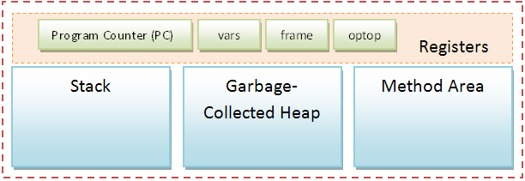

The Stack
Stack in Java virtual machine stores various method arguements as well as the local variables of any method. Stack also keep track of each an every method invocation. This is called Stack Frame. There are three registers thats help in stack manipulation. They are vars, frame, optop. This registers points to different parts of current Stack.
There are three sections in Java stack frame:

Local Variables
The local variables section contains all the local variables being used by the current method invocation. It is pointed to by the vars register.

Execution Environment
The execution environment section is used to maintain the operations of the stack itself. It is pointed to by the frame register.

Operand Stack
The operand stack is used as a work space by bytecode instructions. It is here that the parameters for bytecode instructions are placed, and results of bytecode instructions are found. The top of the operand stack is pointed to by the optop register.

Method Area
This is the area where bytecodes reside. The program counter points to some byte in the method area. It always keep tracks of the current instruction which is being executed (interpreted). After execution of an instruction, the JVM sets the PC to next instruction. Method area is shared among all the threads of a process. Hence if more then one threads are accessing any specific method or any instructions, synchorization is needed. Synchronization in JVM is acheived through Monitors.
. Till Java 6.0, mark and sweep algorithm is used as a garbage collection logic. Remember that the local object reference resides on Stack but the actual object resides in Heap only. Also, arrays in Java are objects, hence they also resides in Garbage-collected Heap.

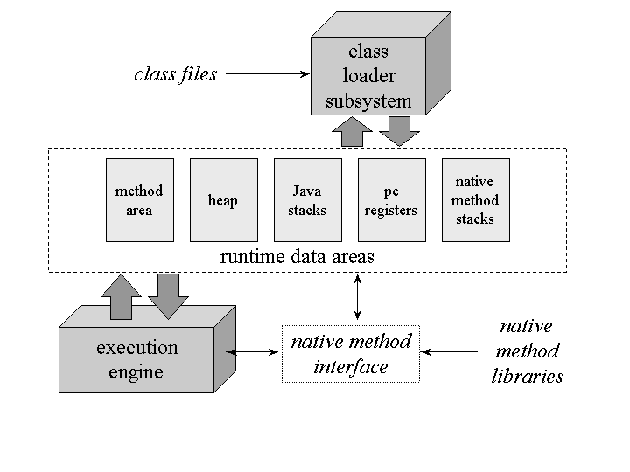
JVM is the main component of Java architecture and it is the part of the JRE (Java Runtime Environment) . It provides the cross platform functionality to java. This is a software process that converts the compiled Java byte code to machine code. Byte code is an intermediary language between Java source and the host system. Most programming language like C and Pascal converts the source code into machine code for one specific type of machine as the machine language vary from system to system . Mostly compiler produce code for a particular system but Java compiler produce code for a virtual machine . JVM provides security to java.
The programs written in Java or the source code translated by Java compiler into byte code and after that the JVM converts the byte code into machine code for the computer one wants to run. JVM is a part of Java Run Time Environment that is required by every operating system requires a different JRE .
The architecture of the JVM is given below . This architecture tell us how the JVM works . Firstly we write the simple java program(source code) the java compiler converts the source code into the bytecode , after that JVM reads this bytecode and converts this into the machine code.
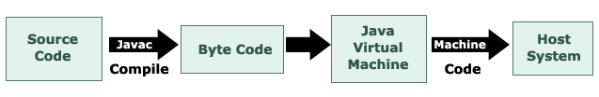
JVM is java interpreter as it converts the byte code into machine code for the computer one wants to run.
JRE consists of a number of classes based on JavaAPI and JVM, and without JRE, it is impossible to run Java. So its portability really made it possible in developing write once and run anywhere software .
How to write First Java program
Create a simplest java program :
public class MyFirstProgram
{
public static void main(String arr[] )
{
System.out.println(" I am creating my first java program");
}
}
Memory Management with JVM :-
the Java language in combination with runtime eliminates the problems of memory management and corrupted pointers.
- There is no explicit allocation of memory in Java, memory is allocated only to objects.
- JVM's heap stores all objects created.
- JVM ask the operating system for enough memory to run the JVM itself and some free memory for the application to create new objects.
- If the free memory area is getting too small, the JVM will ask the operating system for more and if there is no more additional memory available from the operating system, then JVM stops the application and issues the "Out of memory error".
- The Java runtime employs a garbage collector to reclaim the memory occupied by an object.

JVM has various sub components internally. You can see all of them from the above diagram.
1. Class loader sub system: JVM's class loader sub system performs 3 tasks
a. It loads .class file into memory.
b. It verifies byte code instructions.
c. It allots memory required for the program.
2. Run time data area: This is the memory resource used by JVM and it is divided into 5 parts
a. Method area: Method area stores class code and method code.
b. Heap: Objects are created on heap.
c. Java stacks: Java stacks are the places where the Java methods are executed. A Java stack contains frames. On each frame, a separate method is executed.
d. Program counter registers: The program counter registers store memory address of the instruction to be executed by the micro processor.
e. Native method stacks: The native method stacks are places where native methods (for example, C language programs) are executed. Native method is a function, which is written in another language other than Java.
3. Native method interface: Native method interface is a program that connects native methods libraries (C header files) with JVM for executing native methods.
4. Native method library: holds the native libraries information.
5. Execution engine: Execution engine contains interpreter and JIT compiler, which covert byte code into machine code. JVM uses optimization technique to decide which part to be interpreted and which part to be used with JIT compiler. The HotSpot represent the block of code executed by JIT compiler.
The above information is just very basic guide of what JVM consists of. Please refer "Inside JVM" book in order to learn more about JVM in detail.

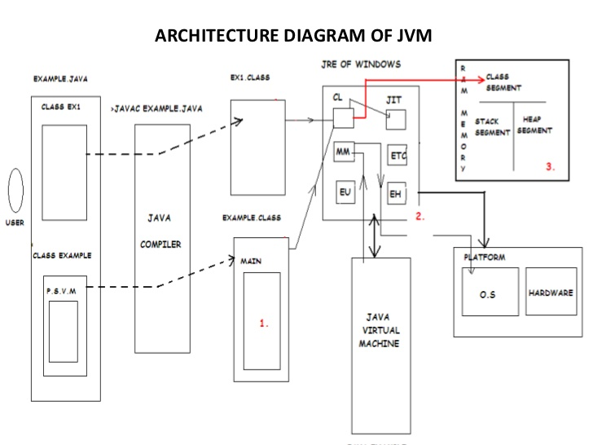

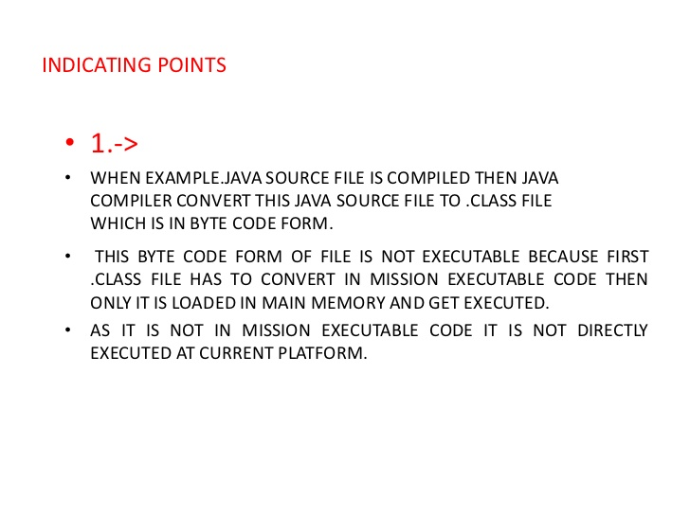
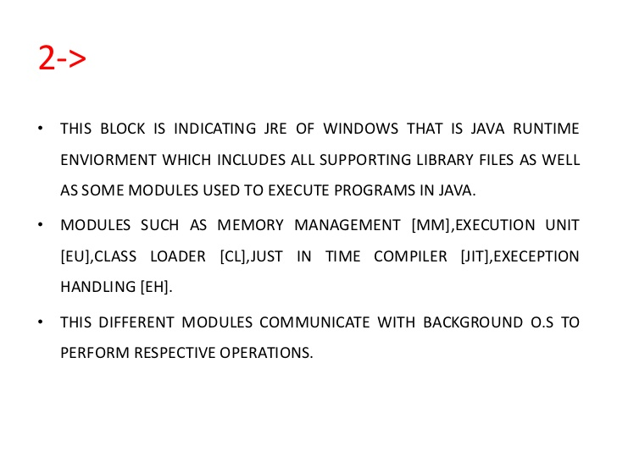
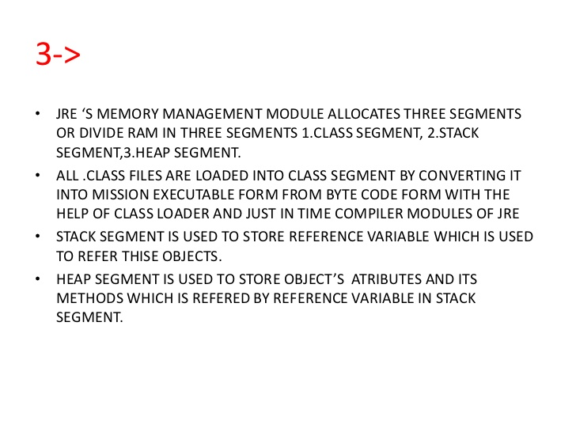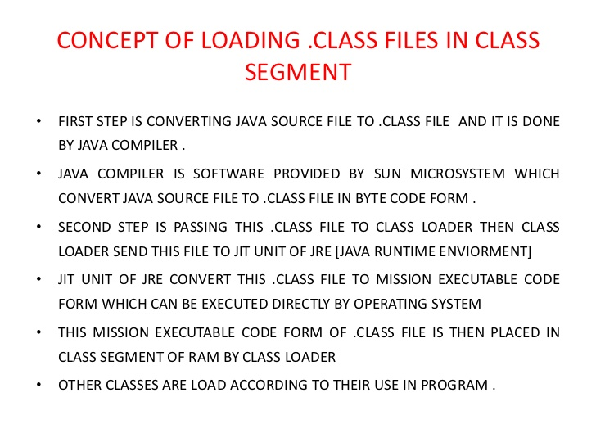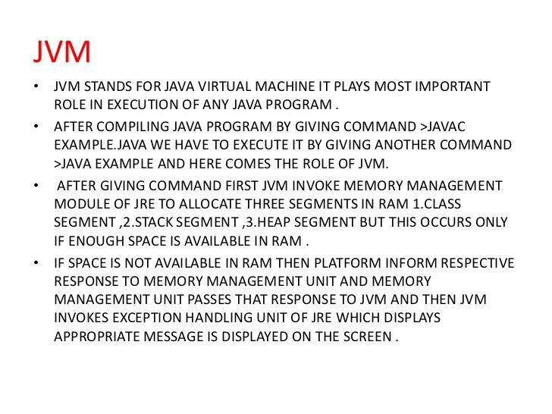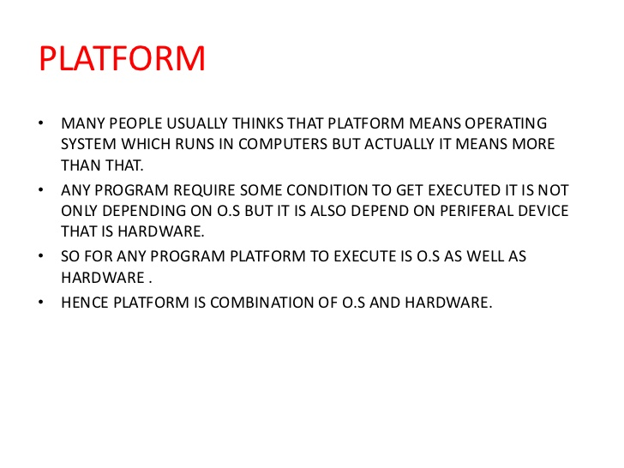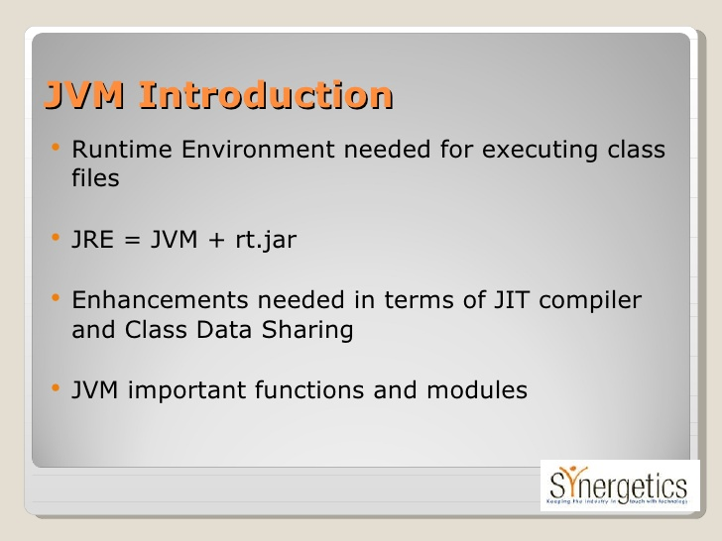
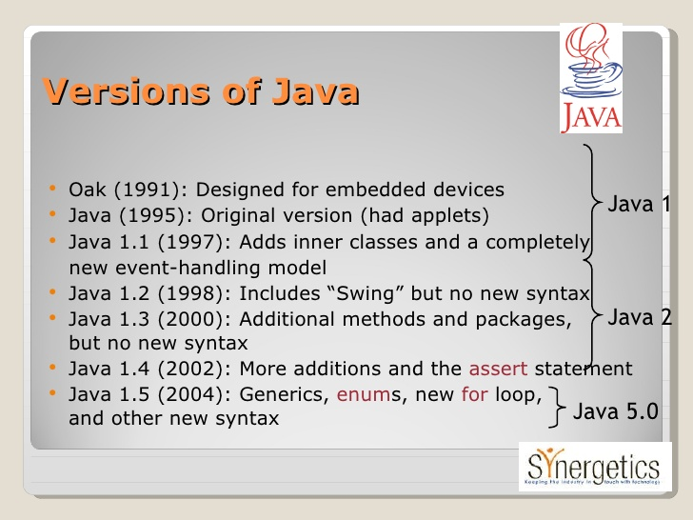

Integrating Native Methods into Java Programs
A native method is a Java method (either an instance method or a class method) whose implementation is written in another programming language such as C.

Although it is rare, occasionally, you may want to call a subroutine that is written in a language other than Java. Typically, such a subroutine exists as executable code for the CPU and environment in which you are working—that is, native code. For example, you may want to call a native code subroutine to achieve faster execution time. Or, you may want to use a specialized, third-party library, such as a statistical package. However, because Java programs are compiled to bytecode, which is then interpreted (or compiled on-the-fly) by the Java run-time system, it would seem impossible to call a native code subroutine from within your Java program. Fortunately, this conclusion is false. Java provides the native keyword, which is used to declare native code methods. Once declared, these methods can be called from inside your Java program just as you call any other Java method.
To declare a native method, precede the method with the native modifier, but do not define any body for the method. For example:
public native int meth() ;
After you declare a native method, you must write the native method and follow a rather complex series of steps to link it with your Java code.
Most native methods are written in C. The mechanism used to integrate C code with a Java program is called the Java Native Interface (JNI). This methodology was created by Java 1.1 and then expanded and enhanced by Java 2. (Java 1.0 used a different approach, which is now completely outdated.) A detailed description of the JNI is beyond the scope of this book, but the following description provides sufficient information for most applications.
Note: The precise steps that you need to follow will vary between different Java environments and versions. This also depends on the language that you are using to implement the native method. The following discussion assumes a Windows 95/98/NT environment. The language used to implement the native method is C.
The easiest way to understand the process is to work through an example. To begin, enter the following short program, which uses a native method called test( ):
// A simple example that uses a native method.
public class NativeDemo {
int i;
public static void main(String args[]) {
NativeDemo ob = new NativeDemo();
ob.i = 10;
System.out.println("This is ob.i before the native method:" +
ob.i);
ob.test(); // call a native method
System.out.println("This is ob.i after the native method:" +
ob.i);
}
// declare native method
public native void test() ;
// load DLL that contains static method
static {
System.loadLibrary("NativeDemo");
}
}
Notice that the test( ) method is declared as native and has no body. This is the method that we will implement in C shortly. Also notice the static block. As explained earlier in this book, a static block is executed only once, when your program begins execution (or,more precisely, when its class is first loaded). In this case, it is used to load the dynamic link library that contains the native implementation of test( ). (You will see how to create this library soon.)
The library is loaded by the loadLibrary( ) method, which is part of the System class. This is its general form:
static void loadLibrary(String filename)
Here, filename is a string that specifies the name of the file that holds the library. For the Windows 95/98/NT environment, this file is assumed to have the .DLL extension. After you enter the program, compile it to produce NativeDemo.class. Next, you must use javah.exe to produce one file:NativeDemo.h. (javah.exe is included in the JDK.) You will include NativeDemo.h in your implementation of test( ). To produce NativeDemo.h, use the following command:
javah -jni NativeDemo
This command produces a header file called NativeDemo.h. This file must be included in the C file that implements test( ). The output produced by this command is shown here:
/* DO NOT EDIT THIS FILE - it is machine generated */
#include <jni.h>
/* Header for class NativeDemo */
#ifndef _Included_NativeDemo
#define _Included_NativeDemo
#ifdef _ _cplusplus
extern "C" {
#endif
/*
* Class: NativeDemo
* Method: test
* Signature: ()V
*/
JNIEXPORT void JNICALL Java_NativeDemo_test
(JNIEnv *, jobject);
#ifdef _ _cplusplus
}
#endif
#endif
Pay special attention to the following line, which defines the prototype for the test( ) function that you will create:
JNIEXPORT void JNICALL Java_NativeDemo_test(JNIEnv *, jobject);
Notice that the name of the function is Java_NativeDemo_test( ). You must use this as the name of the native function that you implement. That is, instead of creating a C function called test( ), you will create one called Java_NativeDemo_test( ). The NativeDemo component of the prefix is added because it identifies the test( ) method as being part of the NativeDemo class. Remember, another class may define its own native test( ) method that is completely different from the one declared byNativeDemo. Including the class name in the prefix provides a way to differentiate between differing
versions. As a general rule, native functions will be given a name whose prefix includes the name of the class in which they are declared.
After producing the necessary header file, you can write your implementation of test( ) and store it in a file named NativeDemo.c:
/* This file contains the C version of the
test() method.
*/
#include <jni.h>
#include "NativeDemo.h"
#include <stdio.h>
JNIEXPORT void JNICALL Java_NativeDemo_test(JNIEnv *env, jobject
obj)
{
jclass cls;
jfieldID fid;
jint i;
printf("Starting the native method.\\n");
cls = (*env)->GetObjectClass(env, obj);
fid = (*env)->GetFieldID(env, cls, "i", "I");
if(fid == 0) {
printf("Could not get field id.\\n");
return;
}
i = (*env)->GetIntField(env, obj, fid);
printf("i = %d\\n", i);
(*env)->SetIntField(env, obj, fid, 2*i);
printf("Ending the native method.\\n");
}
Notice that this file includes jni.h, which contains interfacing information. This file is provided by your Java compiler. The header file NativeDemo.h was created by javah, earlier.
In this function, the GetObjectClass( ) method is used to obtain a C structure that has information about the class NativeDemo. The GetFieldID( ) method returns a C structure with information about the field named "i" for the class. GetIntField( ) retrieves the original value of that field. SetIntField( )stores an updated value in that field. (See the file jni.h for additional methods that handle other types of data.)
After creating NativeDemo.c, you must compile it and create a DLL. To do this by using the Microsoft C/C++ compiler, use the following command line:
Cl /LD NativeDemo.c
This produces a file called NativeDemo.dll. Once this is done, you can execute the Java program, which will produce the following output:
This is ob.i before the native method: 10
Starting the native method.
i = 10
Ending the native method.
This is ob.i after the native method: 20
Note: The specifics surrounding the use of native are implementation- and environment-dependent. Furthermore, the specific manner in which you interface to Java code is subject to change. You must consult the documentation that accompanies

Step By Step
This lesson walks you through the steps necessary to integrate native code with Java programs.
The example used throughout this lesson implements the canonical "Hello World!" program. The "Hello World!" program has two Java classes: the first implements the main() method for the overall program, and the second, called HelloWorld, has one method, a native method, that displays "Hello World!". The implementation for the native method is provided in the C programming language.

Step 1: Write the Java Code
Create a Java class, named HelloWorld, that declares a native method. Also, write the main program that creates a HelloWorld object and calls the native method.

Step 2: Compile the Java Code
Use javac to compile the Java code that you wrote in Step 1.

Step 3: Create the .h File
Use javah to create a .h file.

Step 4: Create a Stubs File
Now, use javah to create a stubs file.

Step 5: Write the C Function
Write the implementation for the native method in a C source file. The implementation will be a regular C function that's integrated with your Java class.

Step 6: Create a Dynamically Loadable Library
Use the C compiler to compile the .h file, the stubs file, and the .c file that you created in Steps 3, 4, and 5 into a dynamically loadable library.

Step 7: Run the Program
And finally, use java, the Java interpreter, to run the program.

Step 1: Write the Java Code
The following Java code segment defines a class named HelloWorld that has one method and a static code segment.
class HelloWorld {
public native void displayHelloWorld();

static {
System.loadLibrary("hello");
}
}

Define a Native Method
You can tell that the implementation for the HelloWorld class's displayHelloWorld() method is written in another programming language because of the native keyword that appears as part of its method definition:
public native void displayHelloWorld();
This method definition provides only the method signature for displayHelloWorld() and does not provide any implementation for it. The implementation for displayHelloWorld() is provided in a separate C language source file.
The method definition for displayHelloWorld() also indicates that the method is a public instance method, accepts no arguments and returns no value.

Step 2: Compile the Java Code
Use the Java compiler to compile the Java class that you created in the step1. At this time, you should also compile the main Java application that you wrote to test the native method.

Step 3: Create the .h File
In this step, you use the javah utility program to generate a C header file (a .h file) from the HelloWorld Java class. The header file defines a structure that represents the HelloWorld class on the C side, and provides a C function definition for the implementation of the native methoddisplayHelloWorld() defined in that class.
By default, javah places the new .h file in the same directory as the .class file. You can tell javah to place the header files in a different directory with the -d option.
The name of the header file is the Java class name with a .h appended to the end of it. For example, the command shown above will generate a file named HelloWorld.h.
/* DO NOT EDIT THIS FILE - it is machine generated */
#include <native.h>
/* Header for class HelloWorld */

#ifndef _Included_HelloWorld
#define _Included_HelloWorld

typedef struct ClassHelloWorld {
char PAD; /* ANSI C requires structures to have a least one member */
} ClassHelloWorld;
HandleTo(HelloWorld);

extern void HelloWorld_displayHelloWorld(struct HHelloWorld *);
#endif

Step 4: Create a Stubs File
In addition to the .h file that you generated in the previous step, you must also use javah to generate a stub file. The stub file contains C code that provides the glue that holds the Java class and its parallel C structure together.
To generate a stub file use javah's -stubs option. Again remember to run javah on the Java class.
By default, javah will place the resulting stub file in the same directory as the .class file. You can use the -d option to force javah to put the generated stub file in a different directory.
Similar to the .h file that javah generates, the name of the stubs file is the class name with .c appended to the end. In the "Hello World!" example that you've been working with throughout this lesson, the stub file is called HelloWorld.c.

Generating a Stub
UNIX
% javah -stubs HelloWorld
DOS shell (Windows 95/NT)
C:\> javah -stubs HelloWorld
Macintosh
[PENDING: Macintosh instructions]

Step 5: Write the C Function
Now, you can finally get down to the business of writing the implementation for the native method in C.
The function that you write must have the same function signature as the one you generated with javah into the HelloWorld.h file in Step 3: Create the .h File. The function signature generated for the HelloWorld class's displayHelloWorld() native method looks like this:
extern void HelloWorld_displayHelloWorld(struct HHelloWorld *);
Here's our implementation for HelloWorld_displayHelloWorld() which can be found in the file named HelloWorldImp.c.
#include &lt;StubPreamble.h&gt;
#include "HelloWorld.h"
#include &lt;stdio.h&gt;

void HelloWorld_displayHelloWorld(struct HHelloWorld *this) {
printf("Hello World!\n");
return;
}
As you can see, the implementation for HelloWorld_displayHelloWorld() is straightforward: the function uses the printf() function to display the string "Hello World!" and then returns.
This file includes 3 C header files:
- StubPreamble.h which provides enough information to the C code to interact with the Java runtime system. When writing native methods, you must always include this file in your C source files.
- The .h file that you generated in Step 3: Create the .h File. This file contains the C structure that represents the Java class for which we are writing the native method and the function definition for the native method you are writing in this step.
- The code snippet above also includes stdio.h because it uses the printf() function.

Step 6: Create a Dynamically Loadable Library
Remember in Step 1: Write the java Class that you use this method call to load a dynamically loadable library named hello into your program at runtime.
System.loadLibrary("hello");
Now you are ready to create the dynamically loadable library. Use the C compiler to compile the C source code created in the previous steps,HelloWorld.c and HelloWorldImp.c, into a dynamically loadable library named hello.

Step 7: Run the Program
Now run the Java application with the Java interpreter. You should see the following output:
Hello World!
If you see an exception like this one:
java.lang.NullPointerException
at java.lang.Runtime.loadLibrary(Runtime.java)
at java.lang.System.loadLibrary(System.java)
at HelloWorld.(HelloWorld.java:5)
at
java.lang.UnsatisfiedLinkError displayHelloWorld
at Main.main(Main.java:3)
then you don't have a library path set up. The library path is a list of directories that the Java runtime system searches when loading libraries. Set your library path now, and make sure that the name of the directory where the hello library lives is in it.
If you see this exception:
java.lang.UnsatisfiedLinkError no hello in LD_LIBRARY_PATH
at java.lang.Throwable.(Throwable.java)
at java.lang.Error.(Error.java)
at java.lang.LinkageError.(LinkageError.java)
at java.lang.UnsatisfiedLinkError.(UnsatisfiedLinkError.java)
at java.lang.Runtime.loadLibrary(Runtime.java)
at java.lang.System.loadLibrary(System.java)
at HelloWorld.(HelloWorld.java:5)
at
java.lang.UnsatisfiedLinkError displayHelloWorld
at Main.main(Main.java:3)
then you have a library path set in your environment, but the name of the directory where the hello library lives is not in it. Modify your library path, and make sure that the name of the directory where the hello library lives is in it.

